AI-BASED CAMPUS ENERGY CONSUMPTION
AND ANOMALY DETECTION SYSTEM
Research Article

ARJUN BALAJI S - 2403717672621008

ABSTRACT
Campus buildings such as classrooms, laboratories, libraries, and administration blocks consume electricity on a daily basis. The amount of electricity consumed depends on the number of occupants, operating time, temperature, and utilization of the equipment, among other factors. Therefore, a high amount of electricity consumption does not necessarily indicate wasteful activity. My objective was to develop a system that could predict the normal amount of electricity consumption and reveal abnormal values that may indicate irregular occurrences. I generated a synthetic dataset comprising 6480 entries for the project. I split the data into training, validation, and testing sets in a ratio of 7:1:2 respectively. I trained three machine learning models – Random Forest Regression algorithm, Long Short-Time Memory (LSTM), and Isolation Forest algorithm – to predict normal consumption values, analyze temporal patterns, and detect anomalies within the data. I created a dashboard where users can register, log electricity consumption data, view predictions, analyze anomalies, view performance metrics of the models, and receive energy-saving insights. The dashboard currently displays eight buildings and 6501 readings in the overview section. It also displays the performance metrics of the Random Forest and LSTM models. However, upon reviewing the dashboard, I discovered that the values in the summary section do not tally with the figures below them. Similarly, the values of the Anomaly counts in the overview section and the anomaly centre do not tally. These inconsistencies must be addressed before the application can be deployed. The project can help campus administrators monitor electricity consumption in various campus buildings, predict normal values, and detect anomalies that may be indicative of irregular activities. However, since the application was developed using synthetic data, it should be tested using actual electricity consumption data before it can be deployed in the campus environment. It will also be critical to monitor and record the reduction in electricity consumption levels after deploying the dashboard.

1. INTRODUCTION
The task of managing electricity consumption in a large campus is not a trivial one given the variance of consumption patterns in each building. Classrooms, laboratories, libraries, and admin blocks will have different energy consumption patterns based on their operating hours and other factors. Furthermore, a place like a library will remain open until late evening whereas a classroom is only used during specific hours. Therefore, simply observing aggregated electricity consumption numbers is not enough to conclude if there are abnormal consumption patterns. The objective of my project is to utilize machine learning to predict energy consumption and identify outliers. Random Forest is used to predict consumption figures (for comparison to actual figures) and to train an LSTM network to learn electricity consumption patterns over time. Another algorithm, Isolation Forest, was used to isolate outliers. The results of the analysis (actual, predicted figures, anomalies, severity, and suggested actions) were presented in a dashboard. The current version of the project is a prototype built on a synthetic dataset. This was done to develop the product further and test various elements of the system. However, such an approach does not allow concluding on the capabilities of the system in a real campus environment. In other words, the results presented in the paper for the case study and the screenshots of the dashboard are based on a prototype. To evaluate the system’s performance, it has to be tested with consumption data (in kWh) of a real sample campus.

2. RELATED WORK / LITERATURE REVIEW
Research on building energy analytics has considered regression, deep learning, time-series modelling, and anomaly detection. Surveys published in 2020-2022 report on the rising interest in machine learning and deep learning based building-energy forecasting, with studies from 2023 onward exploring more specialized approaches to anomaly detection and temporal representations. The following works offer context to the current prototype’s design choices, the results of which should not be directly compared to this project’s findings numerically, unless an identical dataset and evaluation procedure are considered. Xu and Chen [1] evaluated a hybrid data-mining approach to energy anomaly detection, while Himeur et al. [2] surveyed the field of artificial intelligence driven building-energy anomaly detection, outlining opportunities for future research. Khalil et al. [3], Ardabili et al. [4], and others [5], [6] provide surveys of the wide range of statistical, machine-learning, and deep learning approaches used for energy prediction. Recent works consider dedicated anomaly frameworks [7], dynamic detection approaches [8], time-series image representations [9], multivariate time series [10], and hybrid forecasting architectures [11]. These works provide insight into the general motivation for the current research. The current project’s scope is different in that it focuses on a working campus dashboard and a synthetic dataset used for a controlled prototype evaluation. Its results should be considered as implementation examples and not be directly compared to the findings of the works mentioned above, as it does not make a claim of outperforming the existing approaches.

3. PROBLEM DEFINITION AND OBJECTIVES
Managing energy consumption in a campus setting is challenging due to the varying needs of different facilities and the lack of insight into consumption patterns. Interpreting electricity readings is not always straightforward in terms of evaluating normal or abnormal readings. My project will address the problem of identifying normal energy consumption in a building by applying machine learning algorithms that will learn the patterns of energy consumption and utilise them to predict the anticipated electricity consumption.
The application will use energy consumption records, timestamps, building account details, and any other available contextual or temporal variables as input. Random Forest Regression will be employed to predict the expected energy consumption, while Long-Short Term Memory (LSTM) will capture sequential regularities in electricity consumption data and detect anomalies. The results will be presented in a dashboard, allowing the users to view the predicted consumption, investigate and determine the severity of deviations, and receive suggestions for saving energy.
The target users of the proposed application are campus facility staff, energy managers, and administrators concerned with the consumption of energy at the facility level and the assessment of anomalous readings. The application will undergo a series of performance tests to evaluate its ability to function effectively in a production environment and identify the performance measures that must be monitored using the prototype and the synthetic data set.
Element Description Target users Campus facility staff, energy managers, and administrators. Inputs Synthetic energy consumption records, timestamps, building account and other available contextual or temporal variables. The application also allows the manual input of electricity readings. Prediction output The expected energy consumption predicted by Random Forest Regression and the time-based forecasting results of the LSTM. Anomaly output Abnormal electricity consumption identified by Isolation Forest and deviation indicators used to determine if further investigations are required. Decision-support output The results will be displayed on a dashboard which will include graphical displays of the predicted values, past results, deviation reports, the level of severity, and recommendations for energy conservation. Task types Regression, time-series modelling, anomaly detection, and energy consumption forecasting.

Research Questions

1. Can Random Forest Regression be used to forecast energy consumption based on the range of features provided in the dataset?
2. Can Long-Short Term Memory (LSTM) be utilized to capture sequential regularities in electricity consumption records?
3. Can Isolation Forest be used to detect anomalies in energy consumption?
4. Can the visualisation dashboard assist in interpreting the results and supporting organisational decisions?
5. Can the application provide useful suggestions for conserving energy based on the provided readings and detected anomalies?

OBJECTIVES

The project will achieve the following objectives:

1. Predict energy consumption: The project will assess the performance of Random Forest Regression in forecasting energy consumption and the efficacy of LSTM in capturing sequential regularities in electricity consumption records. The performance of the Random Forest Regressor will be evaluated using appropriate regression performance metrics, including MAE, RMSE, and R^2 if applicable.
2. Detect anomalies: This objective will determine the ability of Isolation Forest to detect abnormal energy consumption. If the test set contains labels indicating potential anomalies, the performance will be assessed using precision, recall, F1-Score, and a confusion matrix.
3. Display results: This objective will measure the ability of the dashboard to present results, including energy readings, forecasts, anomalies, and their severity levels.
4. Display recommendations: This objective will evaluate the ability of the application to provide context-based recommendations for investigating anomalous energy consumption.
5. Practical application: This objective will explore the application’s ability to provide energy conservation suggestions using the provided data set and will investigate its efficacy in a production environment using real-world data in a subsequent study.

4. DATASET DESCRIPTION
I have generated a synthetic dataset comprising 6,480 instances instead of using an actual publicly available database like BDG2 or ASHRAE as the source. This dataset is used for both training and testing the machine learning algorithms and detecting anomalies.
Description of the data:
- Property Specification
- Source Synthetic data generated for the project
- Number of Instances 6,480
- Train-Test-Valid Split 70%-10%-20%
- Target Variable Energy consumption (kWh)
- Features Building, timestamp, meter interval, temperature, humidity, occupancy, day type, operating state, HVAC state, tariff rate, and notes
- Algorithms used Random Forests Regression, LSTM, Isolation Forest
- Time Range Unknown

DATA PREPARATION AND LIMITATION

The data comprises energy measurements and building details as features. The presence of missing data, duplicates, erroneous entries, and the algorithmic generation of anomaly labels should be validated in the actual code. Similarly, the distribution of normal and anomalous instances, if any, is unknown.
Since the data is synthetically generated, it may not perfectly represent real-world campus energy consumption patterns. If any external data or code is used in the generation process, it should be appropriately cited and licensed. The dataset does not raise any privacy or ethical concerns since it does not contain any personally identifiable information.
With this caveat, the dataset can be used for the proposed purpose. As mentioned, it would be necessary to test the model on actual campus meter data to evaluate performance.

5. METHODOLOGY
The implementation follows a sequence from data preparation to prediction, anomaly analysis, and dashboard presentation. The models serve different purposes and are not interchangeable: Random Forest handles tabular regression, LSTM handles ordered sequences, and Isolation Forest looks for observations that are unusual in feature space.

5.1 Data Preprocessing and Feature Preparation

The given data set includes energy consumption, time, building specifics, temperature, humidity, occupancy, and other relevant features that will be used for Random Forest, LSTM, and Isolation Forest algorithms.
The data set’s missing values, duplicates, outliers, categorical variables encoding, and feature scaling must be appropriately found and addressed in the code. It should also be determined whether text fields like observation notes can be used in the current model preparation stage.
To avoid data leakage, the data set should be split into training and test samples, and the former should be used for fitting all preprocessing steps and models. Since the energy readings are time-dependent, a chronological split can also be used to avoid later data leakage on earlier records.

5.2 Models and Proposed Approach
I intend to develop three machine learning models to analyze and predict the energy consumption of the campus.
- The first is Random Forest Regression, which is used to predict the expected energy consumption based on the input variables. It represents the standard approach to machine learning tasks.
- The second is Long Short-Time Memory (LSTM), which is trained on a sequence of data to predict future energy consumption and track its behavior.
- The third model is Isolation Forest, which is used for detecting anomalies in energy consumption measurements.

Random Forest and LSTM were chosen for their ability to predict energy consumption, while Isolation Forest was used for its capabilities in outlier detection. The performance of the models can be validated using evaluation metrics such as Mean Absolute Error (MAE), Root Mean Squared Error (RMSE), and R^2 for regression tasks. All three models are standard in the field of machine learning, and my personal contribution is the proposed application to the task of energy consumption prediction with a dashboard, analysis of outliers, and suggestions for energy saving. The exact hyperparameters and comparisons should be defined based on the code implementation and evaluation results.

5.3 Proposed Innovation / Application Component
The innovation of my project is the combination of energy prediction, outlier detection, and recommendation in one dashboard. The prediction of energy consumption is carried out by the Random Forest algorithm, the analysis of consumption trends using Long-Short Term Memory architecture, and the identification of outliers with Isolation Forest.
The dashboard can be used by the personnel of the campus to track the energy performance of the facilities, analyze possible waste, receive predicted results, and obtain recommendations. The application’s effectiveness can be measured by the accuracy of the algorithms, detection of outliers, and the impact of recommendations. As the project is using synthetic data, its practical implementation in the facilities requires additional research.

6. EXPERIMENTAL SETUP
Item | Details available from the project materials
Dataset size | 6,480 synthetic records.
Data split | 70% train / 10% validation / 20% test.
Random Forest | 120 estimators; maximum depth 16; 24 engineered features, as shown on the model card.
LSTM | 24-hour sliding sequence; hidden dimension 32; BPTT with Adam; 25 epochs shown.
Isolation Forest | Used for anomaly detection; exact hyperparameters are not visible in the screenshots.
Reported RF inference latency | 0.08 ms for a single observation, as shown in the model-performance summary.
Reported LSTM training duration | 9.54 seconds, as shown in the model-performance summary.
Application stack shown in footer | FastAPI, PyTorch/Scikit-learn, and React.
Hardware / software versions / random seed | Not established by the screenshots; these should be recorded from the actual development environment.

The dashboard overview reports 6,501 hourly meter readings, while the dataset description supplied by the developer states that the synthetic dataset has 6,480 records. These values may refer to different application counts or a different state of the data. The report preserves both displayed figures and recommends confirming the count directly from the dataset and API before final submission.

7. EVALUATION METRICS
Regression metrics summarise how close predicted consumption is to the measured target. They should be computed on the held-out test set and with consistent units.
Mean Absolute Error (MAE): MAE = (1/n) Σ |yᵢ − ŷᵢ|. It represents the average absolute prediction error in the target unit.
Root Mean Squared Error (RMSE): RMSE = √[(1/n) Σ (yᵢ − ŷᵢ)²]. It gives greater weight to larger errors.
Coefficient of determination (R²): R² = 1 − [Σ(yᵢ − ŷᵢ)² / Σ(yᵢ − ȳ)²]. It compares prediction error with a mean-based reference.
Inference latency measures the time taken to generate a prediction for an input. Training duration records the time used to fit a model under a particular environment. For anomaly detection, useful reporting includes the number of flagged records, the proportion flagged, examples of alerts, and review findings. Precision, recall, F1-score, and a confusion matrix should only be reported if reliable ground-truth anomaly labels are available.

8. RESULTS
The following values are transcribed from the supplied application screenshots. They demonstrate that the interface contains model outputs and dashboard summaries, but should be treated as displayed prototype results until the underlying evaluation logs confirm that they were computed from the same held-out test set.
Model / dashboard item | Metric shown | Value shown
Random Forest summary card | R² | 0.9754
Random Forest summary card | MAE | 2.214 kWh
RandomForestRegressor v1.0 model card | MAE | 2.25 kWh
RandomForestRegressor v1.0 model card | RMSE | 3.82 kWh
RandomForestRegressor v1.0 model card | R² | 0.9720
Random Forest inference | Latency | 0.08 ms
LSTM summary card | R² | 0.928
LSTM summary card | MAE | 0.19 kWh
LSTM Sequence Regressor v1.0 model card | MAE | 0.17 kWh
LSTM Sequence Regressor v1.0 model card | RMSE | 0.27 kWh
LSTM Sequence Regressor v1.0 model card | R² | 0.9304
LSTM training | Duration | 9.54 seconds; 25 epochs shown

8.1 Dashboard-Level Values
Dashboard indicator | Value shown in screenshots | Interpretation
Monitored facilities | 8 | Eight campus facilities/blocks are listed as monitored.
Overview total energy | 247,755.1 kWh | Campus-level aggregate displayed by the overview.
Overview estimated cost | ₹1,858,164 | Cost estimate displayed by the overview; tariff and aggregation logic should be verified.
Overview active anomalies | 150 | Top-level summary count.
Anomaly centre total flagged | 136 | A different count appears in the anomaly-centre view.
Anomaly centre critical severity | 14 | Events shown under the critical-severity summary.
Dual-method confirmed | 10 | Count displayed for events where methods agree.
Active investigations | 15 | Open or under-review cases displayed.
Recommendation workspace | ~70 kWh; ₹524 | Potential energy recovery and cost-reduction estimate displayed.
Warning / critical thresholds | 20% / 40% | Configurable residual-based thresholds shown in Settings.

The screenshots show an example anomaly where observed energy is 72.5 kWh against an expected baseline of 20.1 kWh, with a displayed residual of +52.4 kWh and percentage deviation of +261.4%. The explanation suggests checking HVAC, server-lab cooling, or lighting that may have remained active outside normal hours. This is an example of the system’s explanatory workflow, not a verified diagnosis of the actual cause.

8.2 Results Screenshots
The screenshots below are included as evidence of the implemented interface and its displayed outputs. They are not substitutes for exported evaluation logs or a reproducible test run.
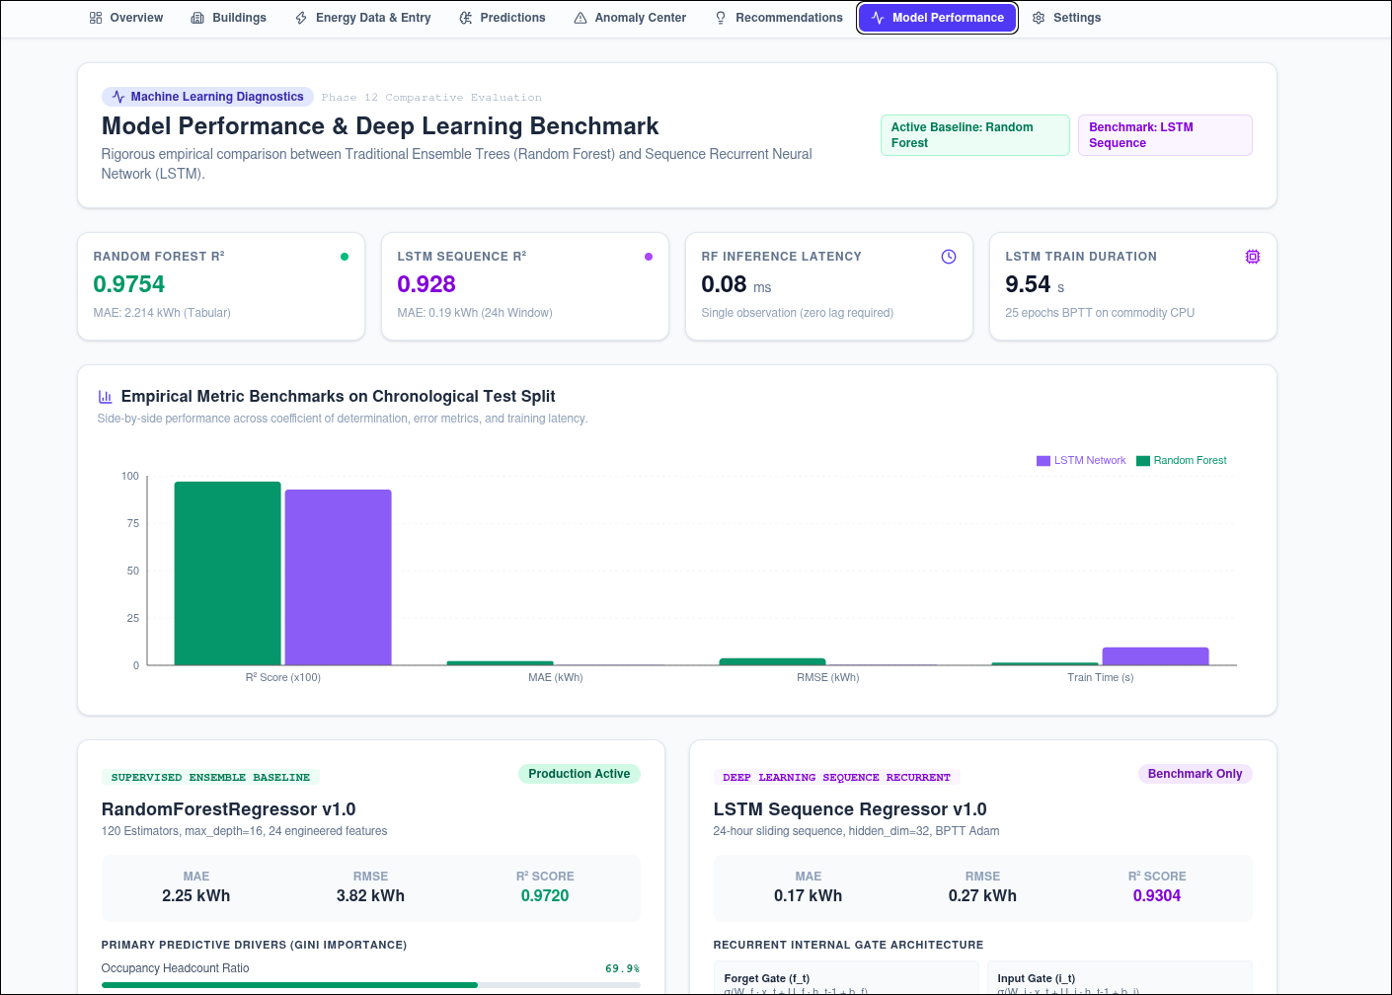
Figure 1. System architecture showing the frontend routes, FastAPI modules, energy intelligence components, and persistence layer.
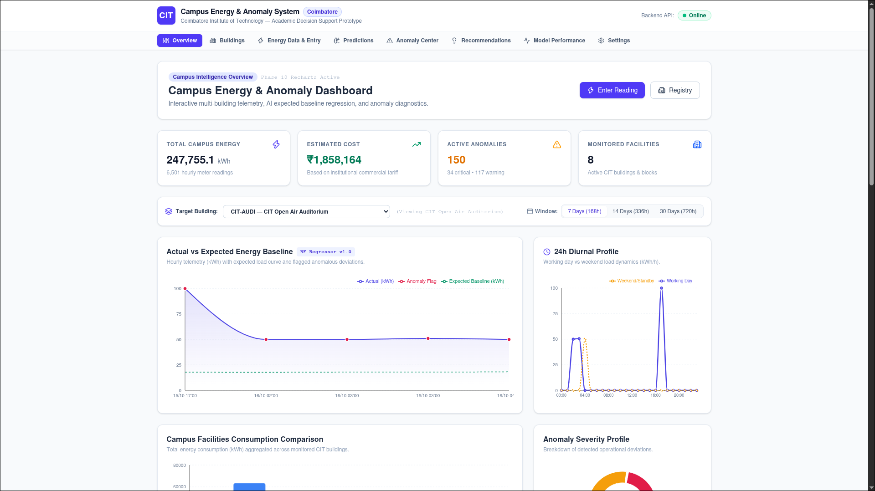
Figure 2. Campus energy overview with summary indicators, actual-versus-expected trend, and diurnal profile.
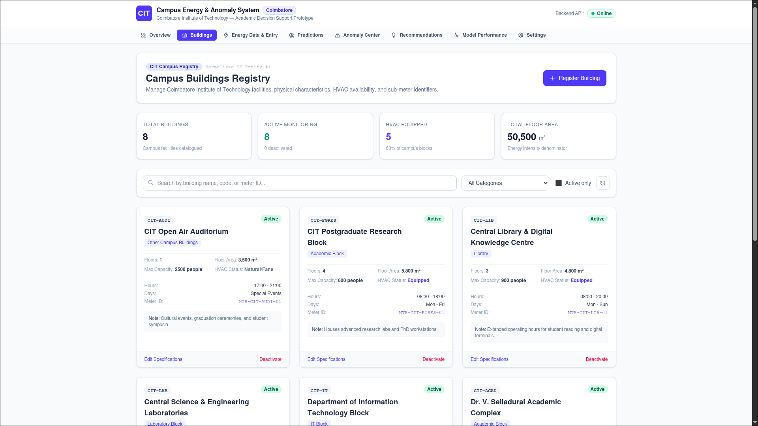
Figure 3. Building registry with building metadata, operating hours, meter identifiers, and monitoring status.
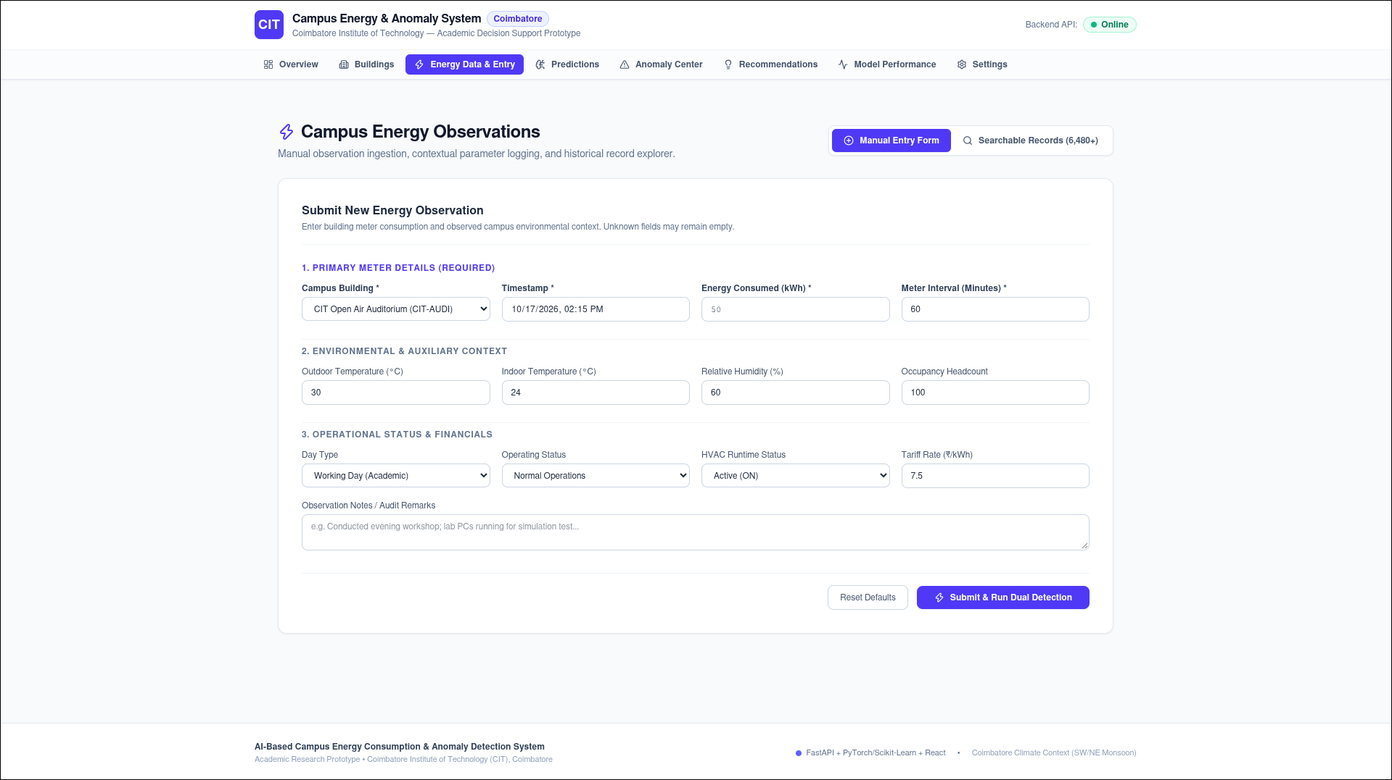
Figure 4. Energy observation form for meter readings and environmental/operational context.
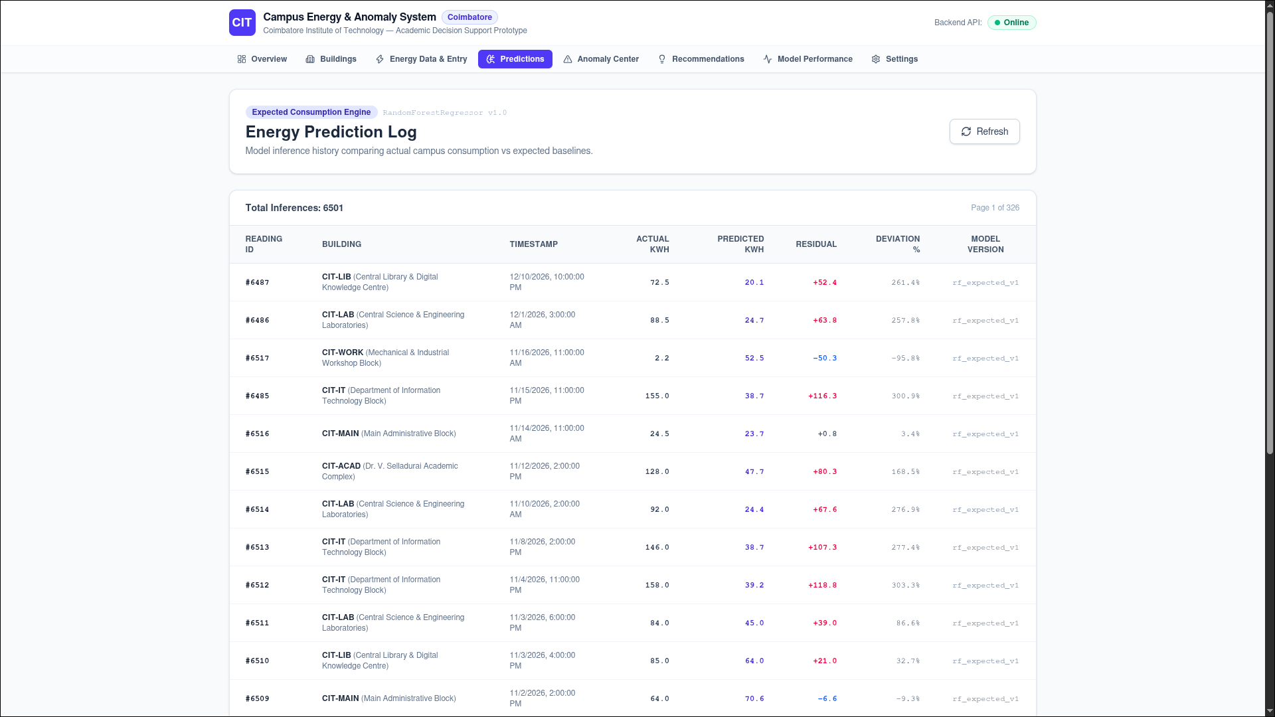
Figure 5. Energy prediction log showing actual and predicted values, residuals, percentage deviation, and model version.
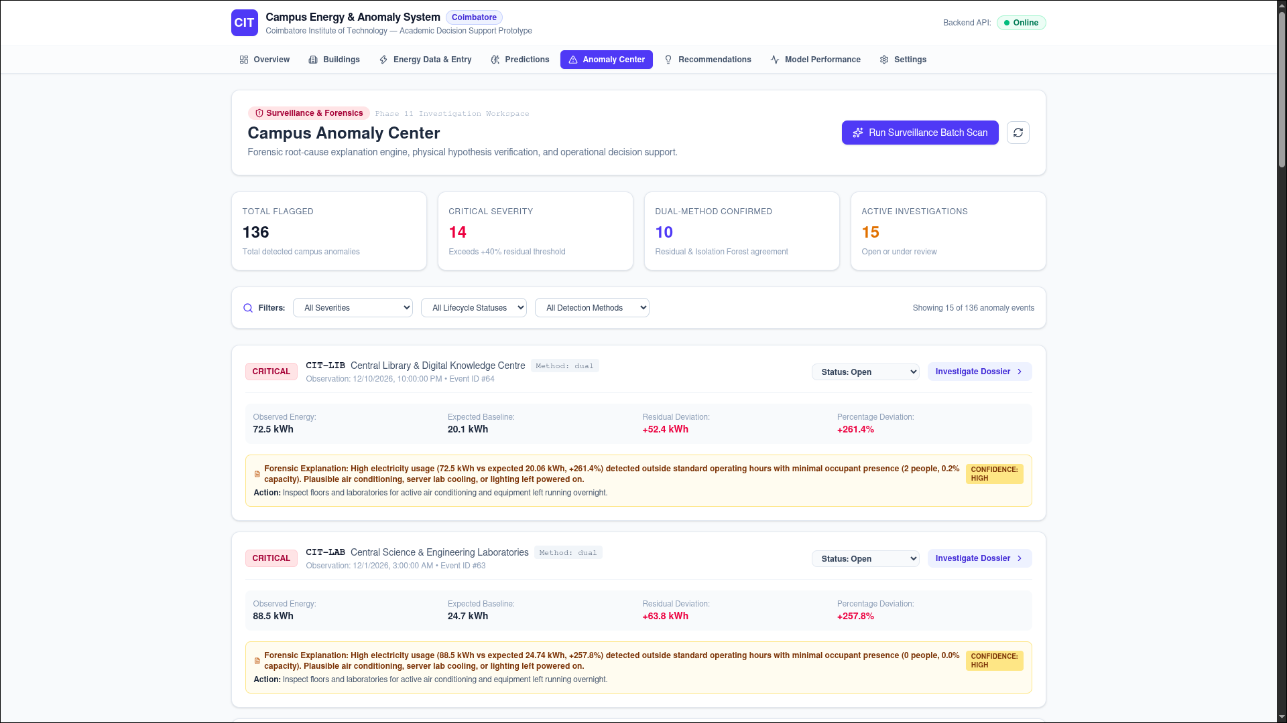
Figure 6. Anomaly investigation view with severity, residual evidence, explanation, and action guidance.

Figure 7. Operational recommendations with supporting evidence, verification checklist, role assignment, and estimated savings.
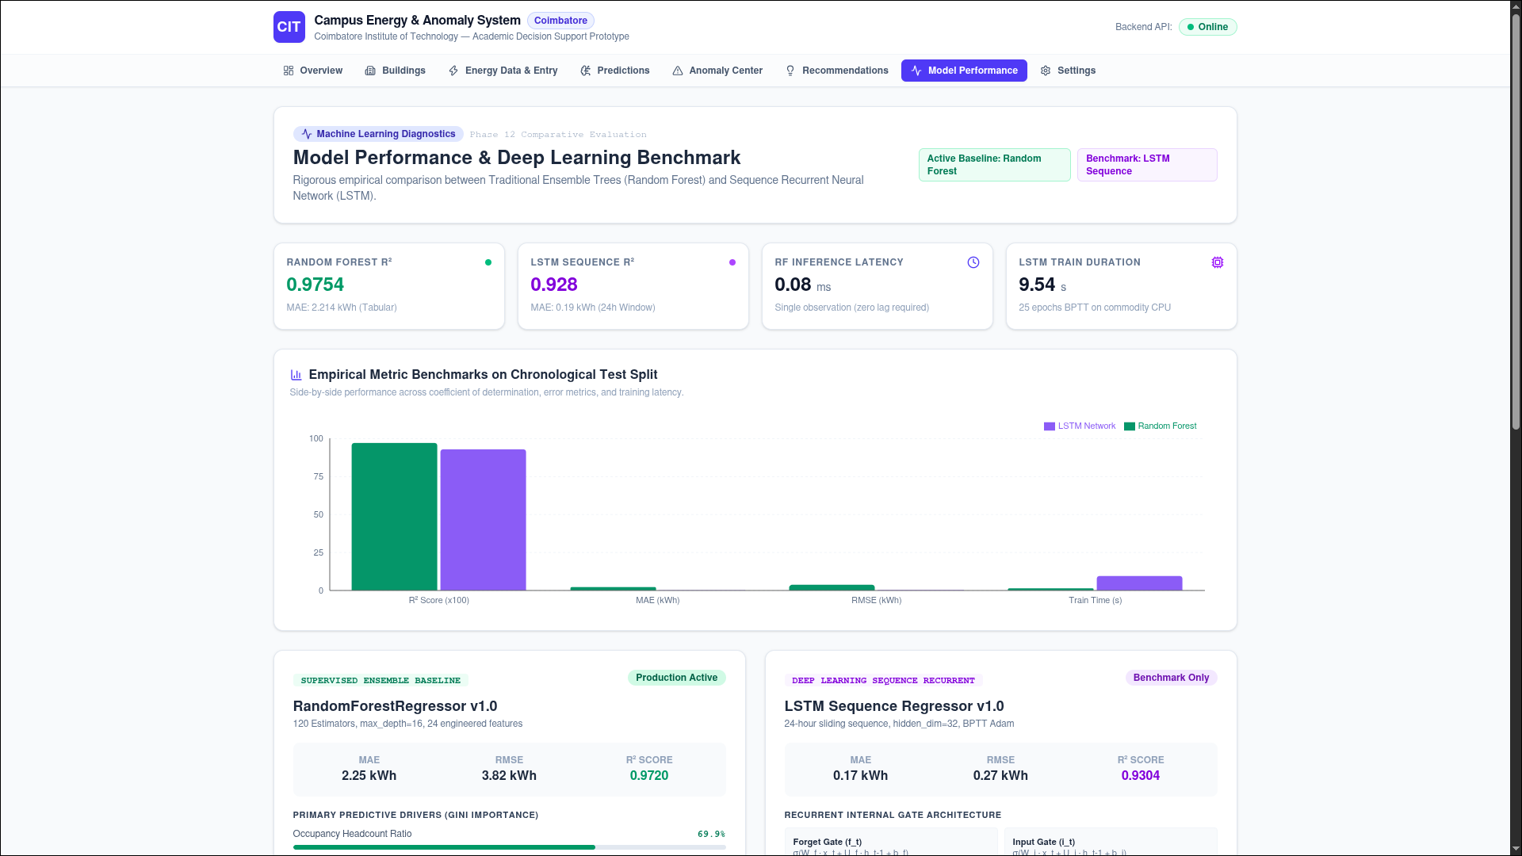
Figure 8. Model-performance comparison for Random Forest and LSTM, including reported metrics and model settings.
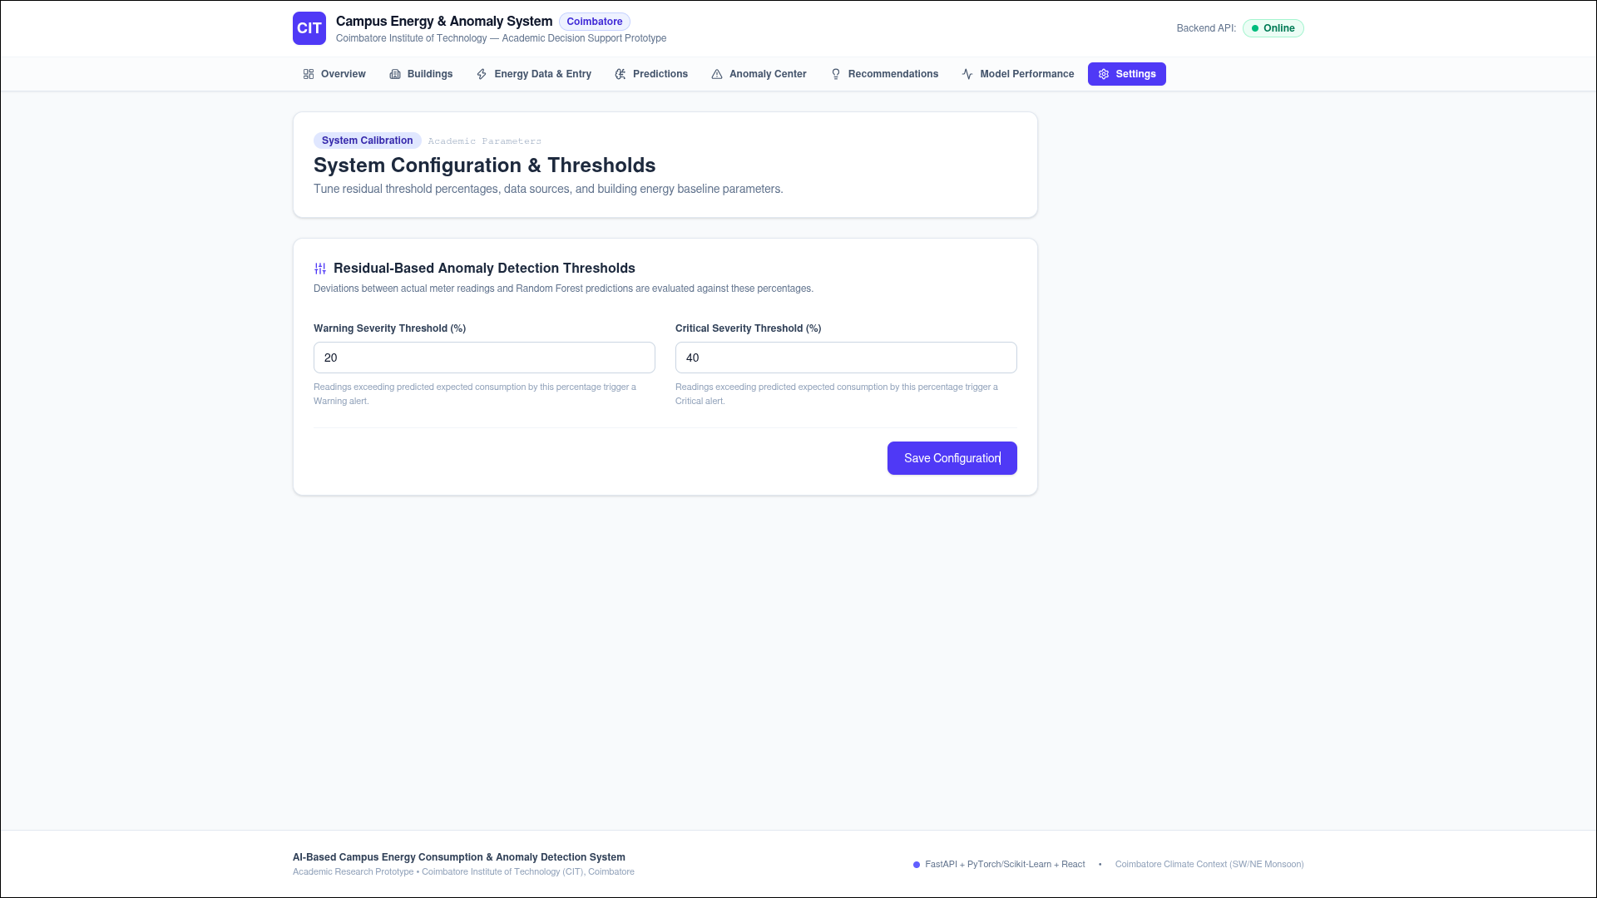
Figure 9. System settings showing warning and critical residual thresholds.

9. DISCUSSION
The project’s main idea is to combine energy prediction and outlier detection to offer the campus’s service staff an accurate description of the electrical energy use and detect outliers’ measurements. The Random Forest algorithm is used to predict the amount of electrical power, while Long Short-Time Memory (LSTM) network is trained to learn the patterns. The Isolation Forest approach is taken to identify the outliers.
The evaluation process focuses on accuracy since all three algorithms serve different purposes, and there is no sense in trying to measure their performance within one metric framework. Namely, Random Forest is primarily used for structured data analysis, whereas, for unstructured ones, LSTM is appropriate. Also, the Isolation Forest technique is capable of handling both of them with an isolation mechanism; however, it cannot confirm whether the isolated points are wasteful or not.
The dashboard was created to unite all final outcomes in one place and visualize them for a better understanding of the problem. As mentioned in the project description, only synthetic data was used; therefore, there is no guarantee that the findings will correspond to the real situation in the campus. Thus, further research is needed to spot-test the algorithms’ performance, processing time, and energy efficiency in terms of actual figures. Moreover, in order to make a valid comparison with the existing research, a solid set of data and corresponding evaluation techniques should be chosen.

10. CONCLUSION AND FUTURE WORK
The presented project is the solution for the campus energy consumption monitoring task that employs regression and time series analysis to predict energy consumption, learn consumption patterns, and detect anomalies in energy consumption. Random Forest Regression algorithm is utilized to predict the site’s expected energy consumption and thereby estimate its energy needs. The Long Short-Term Memory (LSTM) architecture is used to learn the patterns of the given time series. Finally, an Isolation Forest algorithm is applied to detect outliers in the energy consumption data.
The software prototype of the project contains the modules for building management, energy data entry, prediction results visualization, consumption pattern analysis, anomaly detection, and energy saving recommendations. In the selected dashboard, eight facilities and 6501 hourly energy consumption entries are visualized, while 6480 records were used in the synthetic dataset for developing the prototype. These numbers should not be considered equal since the two different dashboards visualize the results of the project. Moreover, some of the numbers presented in the two sections of the dashboard differ and should be cross-verified. In general, the project can be considered somewhat successful in demonstrating the use of the machine learning models for campus energy monitoring and analysis of consumption anomalies, which may require special attention.
However, the predictive power of the project remains unproven, since the algorithms were trained on the synthetic dataset. It is recommended that in the future, the project could consider applying the prototype to the real electricity meter data, thus proving its effectiveness and validating the results of the model. Furthermore, the project needs to perform anomaly detection and verify whether the suggested interventions affect the energy consumption in the real facilities and thus may become valuable for the campus energy management task.

DATA AND CODE AVAILABILITY
A related public implementation of campus energy prediction and anomaly detection is available on GitHub. It includes machine learning models, data-processing components, and a dashboard for analysing energy consumption.
Related repository: https://github.com/Amit0730/campus-energy-intelligence-and-anomaly-detection
This repository is provided as a related reference implementation and is not the source code for my project. My project uses a separately created synthetic dataset containing 6,480 records. The dataset and implementation details described in this report relate to my own system.

REFERENCES

2020
[1] Y. Sun, F. Haghighat, and B. C. M. Fung, “A review of the state-of-the-art in data-driven approaches for building energy prediction,” Energy and Buildings, vol. 221, article 110022, 2020. https://doi.org/10.1016/j.enbuild.2020.110022

2021
[2] J. Runge and R. Zmeureanu, “A review of deep learning techniques for forecasting energy use in buildings,” Energies, vol. 14, no. 3, article 608, 2021. https://doi.org/10.3390/en14030608
[3] “Artificial intelligence based anomaly detection of energy consumption in buildings: A review, current trends and new perspectives,” Applied Energy, vol. 287, article 116601, 2021. https://doi.org/10.1016/j.apenergy.2021.116601

2022
[4] S. A. Ardabili, L. Abdolalizadeh, C. Mako, B. Torok, and A. Mosavi, “Systematic review of deep learning and machine learning for building energy,” Frontiers in Energy Research, vol. 10, article 786027, 2022. https://doi.org/10.3389/fenrg.2022.786027
[5] C. Lu, S. Li, and Z. Lu, “Building energy prediction using artificial neural networks: A literature survey,” Energy and Buildings, vol. 262, article 111718, 2022. https://doi.org/10.1016/j.enbuild.2021.111718
[6] M. Khalil, A. S. McGough, Z. Pourmirza, M. Pazhoohesh, and S. Walker, “Machine learning, deep learning and statistical analysis for forecasting building energy consumption—A systematic review,” Engineering Applications of Artificial Intelligence, vol. 115, article 105287, 2022. https://doi.org/10.1016/j.engappai.2022.105287

2023
[7] Z. Zhang et al., “Anomaly detection method for building energy consumption in multivariate time series based on graph attention mechanism,” PLOS ONE, 2023. https://doi.org/10.1371/journal.pone.0286770
[8] “A dynamic anomaly detection method of building energy consumption based on data mining technology,” Energy, vol. 263, article 125575, 2023. https://doi.org/10.1016/j.energy.2022.125575
[9] T. Mendes, P. J. S. Cardoso, J. Monteiro, and J. Raposo, “Anomaly detection of consumption in hotel units: A case study comparing Isolation Forest and variational autoencoder algorithms,” Applied Sciences, vol. 13, no. 1, article 314, 2023. https://doi.org/10.3390/app13010314

2024
[10] R. Mathumitha, P. Rathika, and K. Manimala, “Intelligent deep learning techniques for energy consumption forecasting in smart buildings: A review,” Artificial Intelligence Review, vol. 57, article 35, 2024. https://doi.org/10.1007/s10462-023-10660-8
[11] L. Lei, X. Guo, and R. Zheng, “An innovative dynamic anomaly detection method based on hybrid data mining technology for building energy consumption,” Energy and Buildings, vol. 319, article 114559, 2024. https://doi.org/10.1016/j.enbuild.2024.114559
[12] D. Stjelja, V. Kuzmanovski, R. Kosonen, and J. Jokisalo, “Building consumption anomaly detection: A comparative study of two probabilistic approaches,” Energy and Buildings, vol. 313, article 114249, 2024. https://doi.org/10.1016/j.enbuild.2024.114249

2025
[13] D. Azzalini, B. Flammini, C. A. E. Guadagno, E. Ragaini, and F. Amigoni, “An empirical evaluation of deep autoencoders for anomaly detection in the electricity consumption of buildings,” Energy and Buildings, vol. 327, article 115069, 2025. https://doi.org/10.1016/j.enbuild.2024.115069

